# API Gateway Serverless POST method Calculator method

## Create a Lambda function

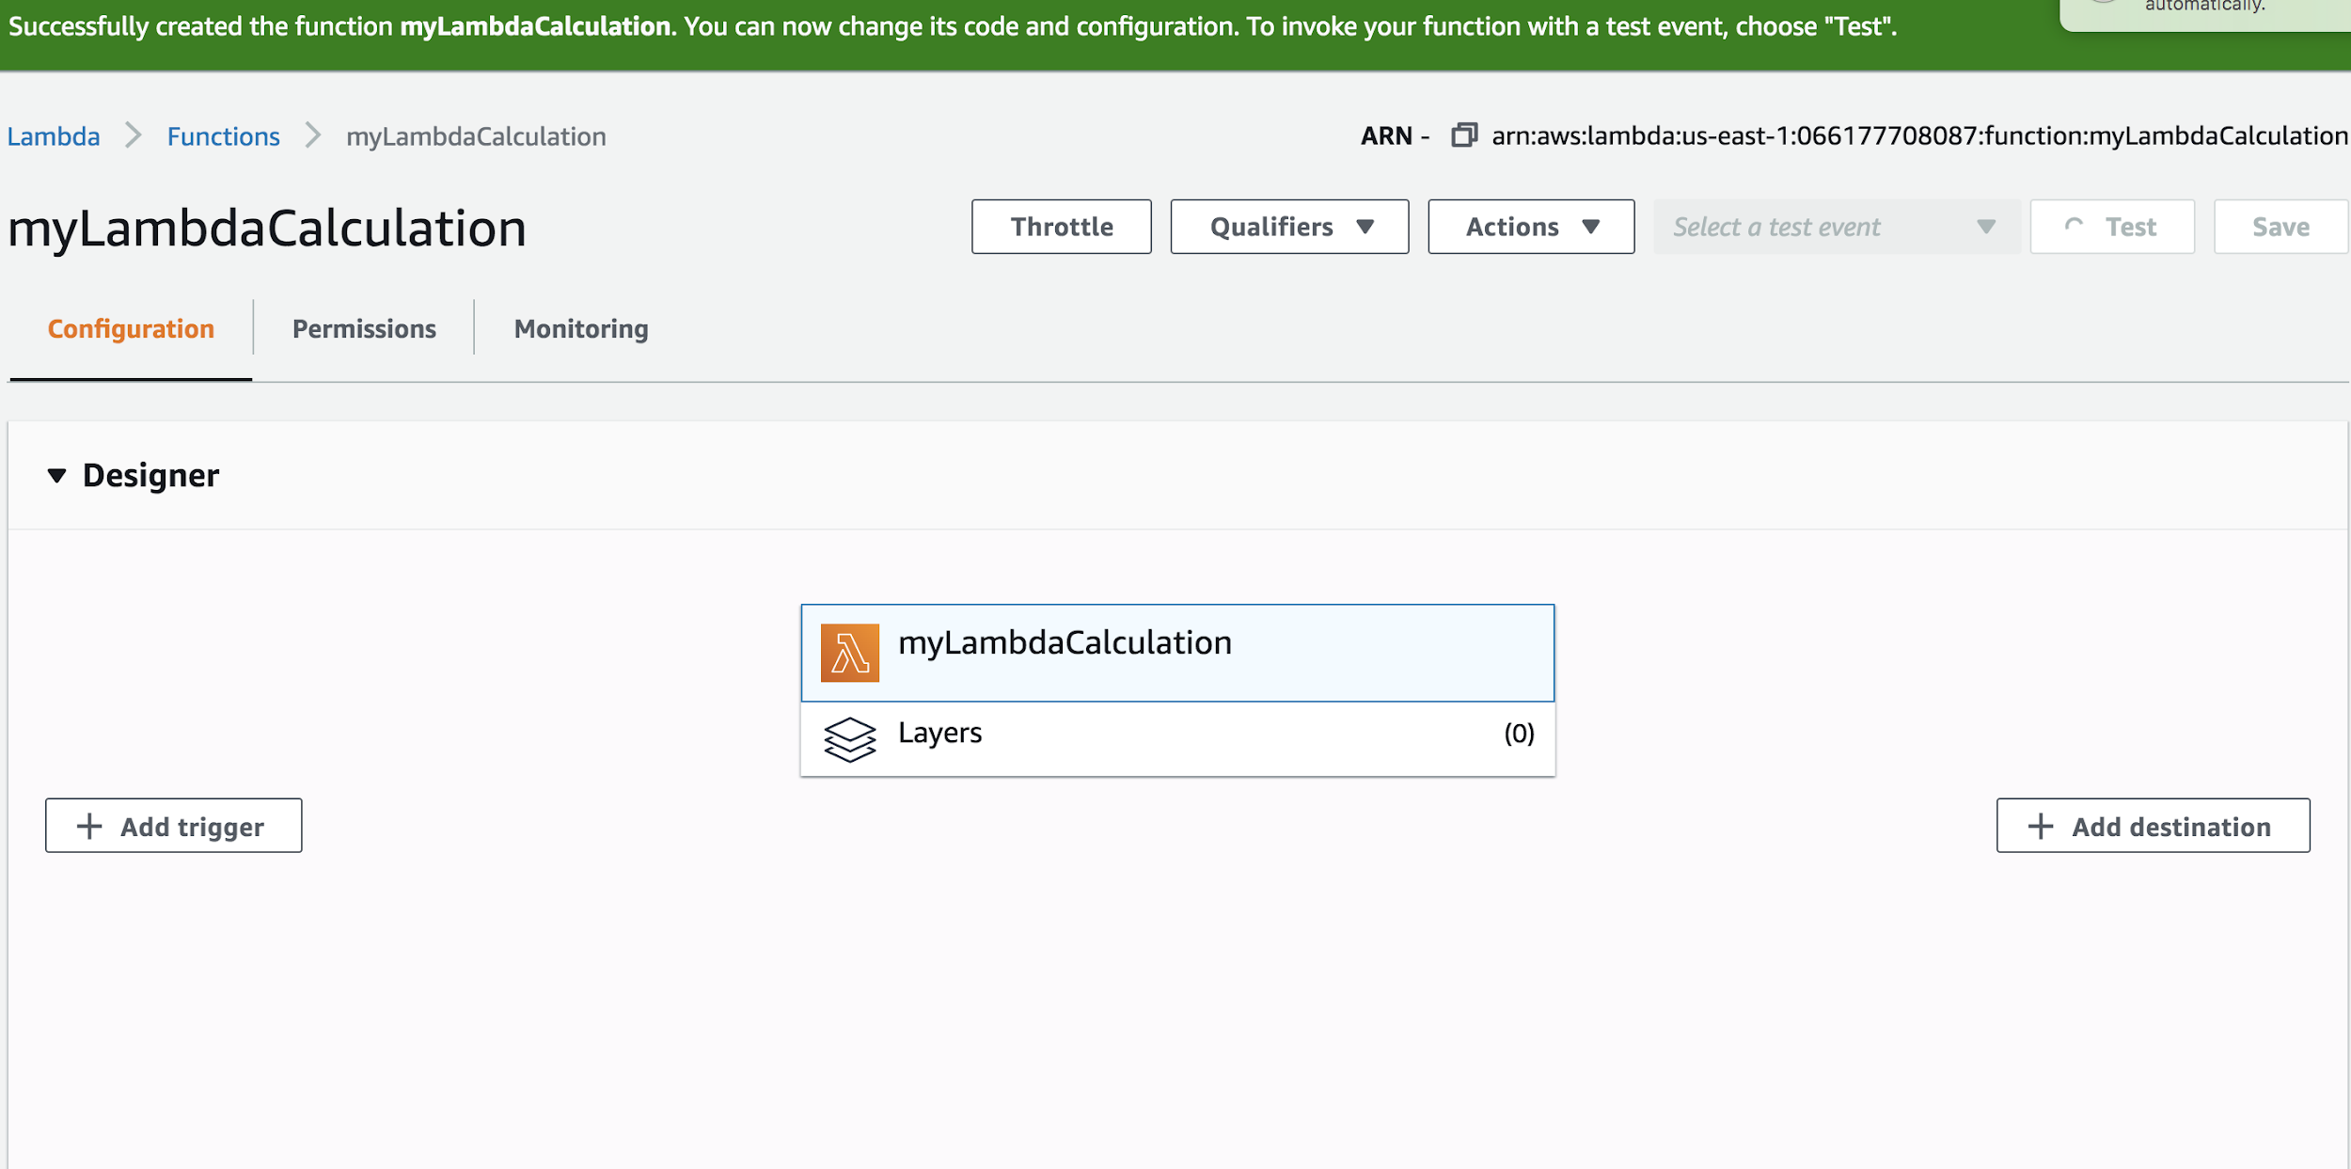

## Nodejs code

exports.handler = async (event) => {

let {operand1, operand2} = event.input;

let result;

switch(event.operation) {

case 'add':

result = operand1 + operand2;

break;

case 'subtract':

result = operand1 - operand2;

break;

case 'multiply':

result = operand1 * operand2;

break;

case 'divide':

result = operand1 / operand2;

break;

default:

result = null;

}

const response = {

statusCode: 200,

body: JSON.stringify(result)

};

return response;

};

==============

## API GATEWAY

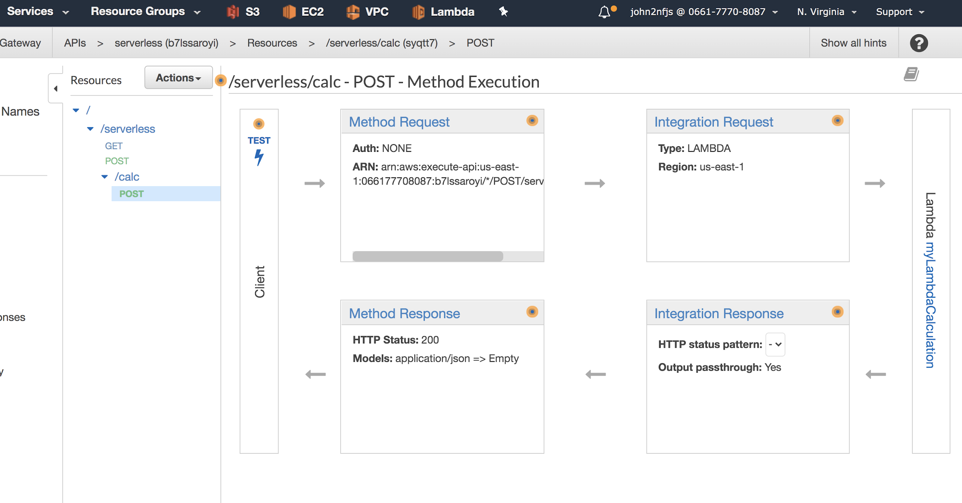

{

"operation": "add",

"input": {

"operand1": 10,

"operand2": 5

}

}